Lost & Found Freelancing

Web Application

1- Introduction

1.1 Project Summary

This web application is a part of freelance market place where client can post a project, and freelancers can work on project, and same way freelancers can post their gig and the client can assign them work.

This help skilled people to earn from home without working under any organization, and get paid for the work and time they put in.

This web application is made to help people with skills to get employment and business owner to get their work done by talented artists.

1.2 Purpose

To create a online marketplace for digital service offered by buyers and sellers. It will be medium to connect people with skills to people with requirement.

* Create source to connect sellers and buyers
* Sell skills to client as a gig
* Post a project
* provide side hustle to make money
* automate the employment and hiring process

1.3 Benefits

For Freelancer -

* Provide flexible work hours

work any time you are comfortable with, no need to work a fix time like 9-5

* Work from home

you don't need to walk in office everyday you can work with comfort of home environment

* control over work and clients

you have options to choose whom to work with and interest of the work.

* you are the boss

It involve only developer and client, you can keep all percent of revenue, no third-party involved, you do not need to answer anyone else.

For Clients -

* Get work done sitting home

no need for assign workspace or office room and still get work done by freelancers form their side.

* Reduce Time process

the client no longer need to go search for skilled people or advertise for employment. And can simply assign work to a person already looking for work

1.4 Scope

This freelancing market platform is global, with no limitation.

only thing that is required to get platform running is to bring traffic on site,

* that can be done by marketing and promotion services
* there is no need of admin that is a big advantage as it is one time work and lifetime paying asset

2- Project Planning

2.1 Web Development Model

I am using iterative model to develop website as it is convenient for developing web application where development is done step by step.

* I don't follow exact typical model
* First I get with the idea, gather requirements and start coding/implementation of a module one by one.
* I do requirement specification in between development whenever stuck on a problem
* After finishing all modules I combine all modules together to form one complete website.
* Testing is done in implementation phrase only
* The design is adjusted as it fit in.
* And no maintenance required once website is deployed.

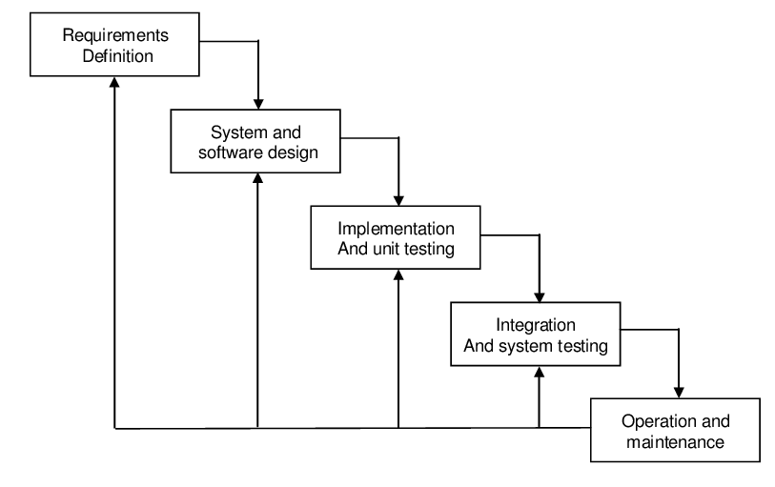

2.2 Programming

Front End-

* HTML

I'm using html to structure our website and elements in the static page.

* CSS

Using CSS I design the web page improve GIU, make page more attractive and responsive.

* JavaScript

I use JS to create webpage dynamic and interactive.

Back End-

* PHP

It is a server-side scripting language, I used to make connection with database, and interact with data.

* MYSQL

It is a relational database management system,

used to handle user data and database,

3- System Requirement

3.1 Software Requirements

* XAMPP

It is a local host / server. It is used to run .PHP files working with being connected to database.

* PHPMyAdmin

it is a software tool used to handle database server, it is administration of MySQL.

* Visual Studio Code

- html5 extension pack

- html css support

- html/css/javascript snippet

- php extension pack

- mysql db

- live server

* Web Browser: Chrome

It provide interface between client and server, giving response to client request and provide document.

* Hosting And Domain service

used to host the web application live and get a domain name

3.2 Hardware Requirements

* desktop pc
* cpu:

- processor: intel core i5

- ram: 8gb

- operating system: windows 7 64bit

4- System Design

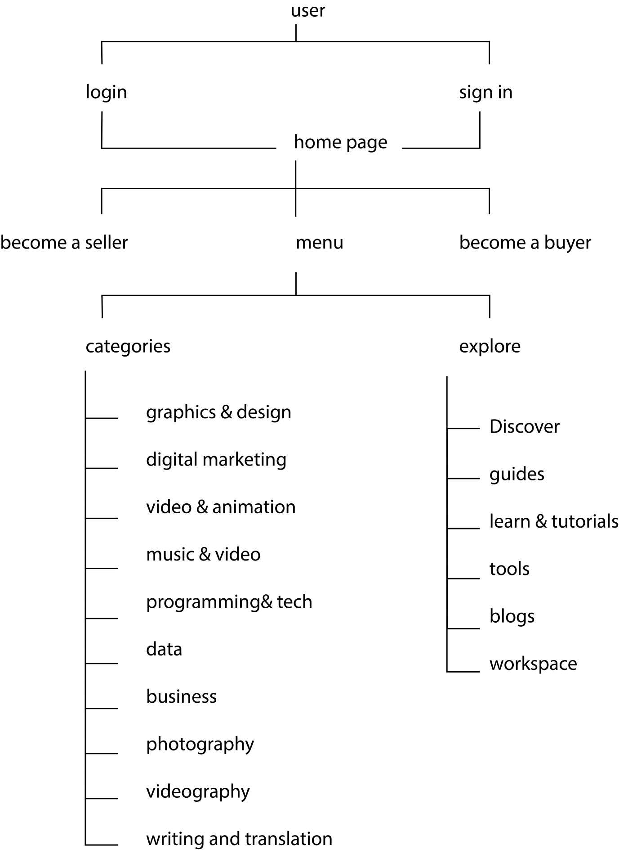

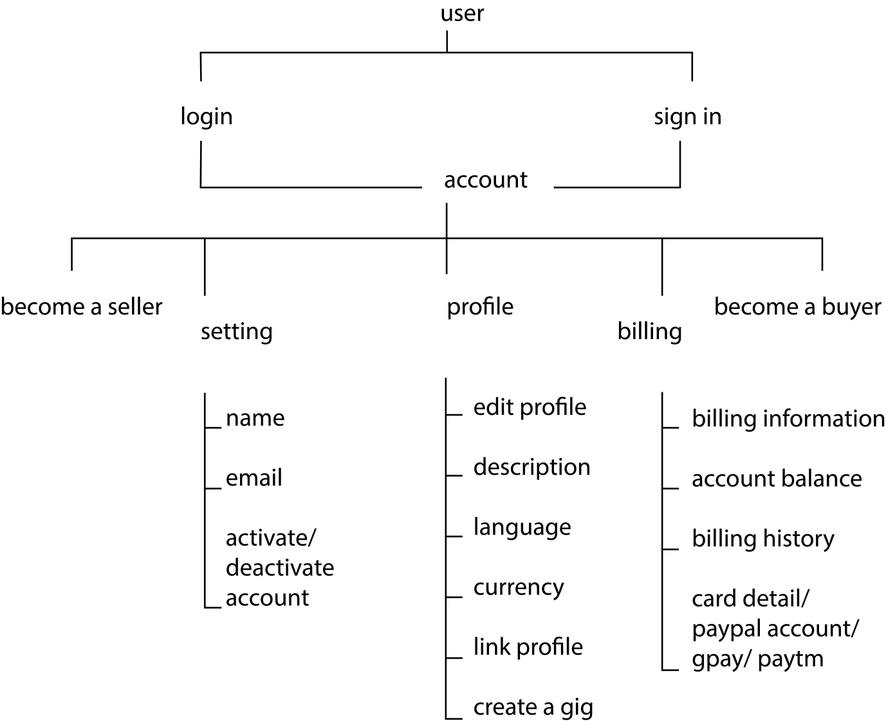

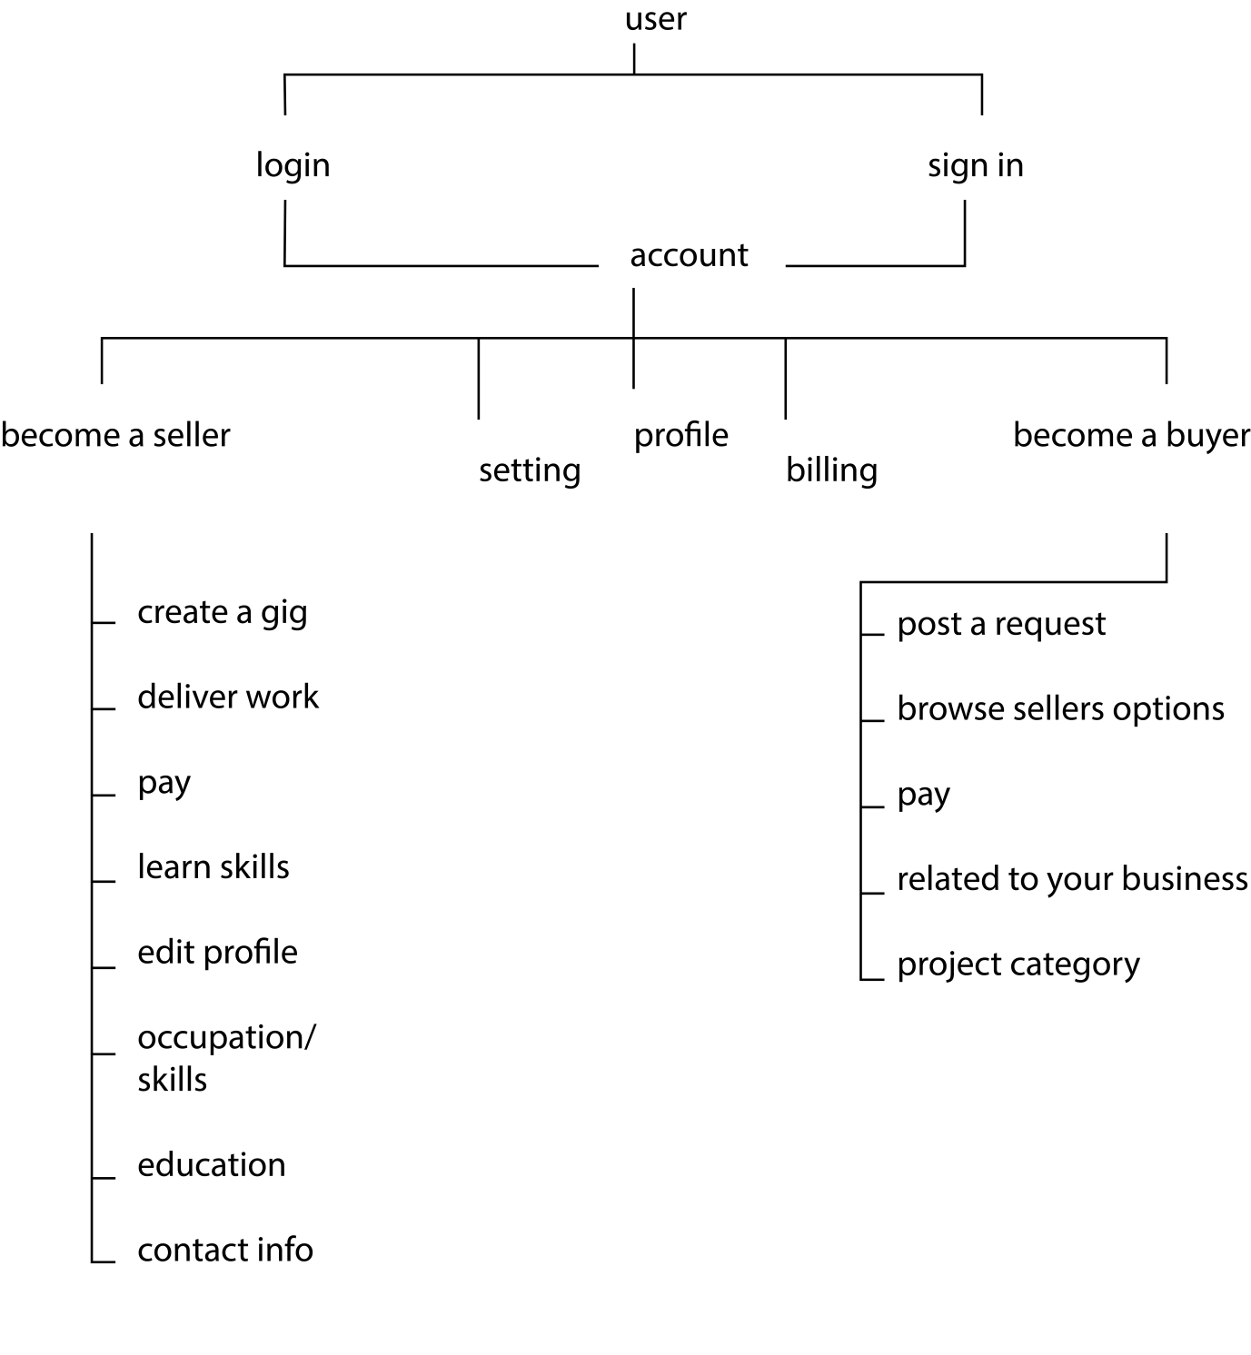

seller side

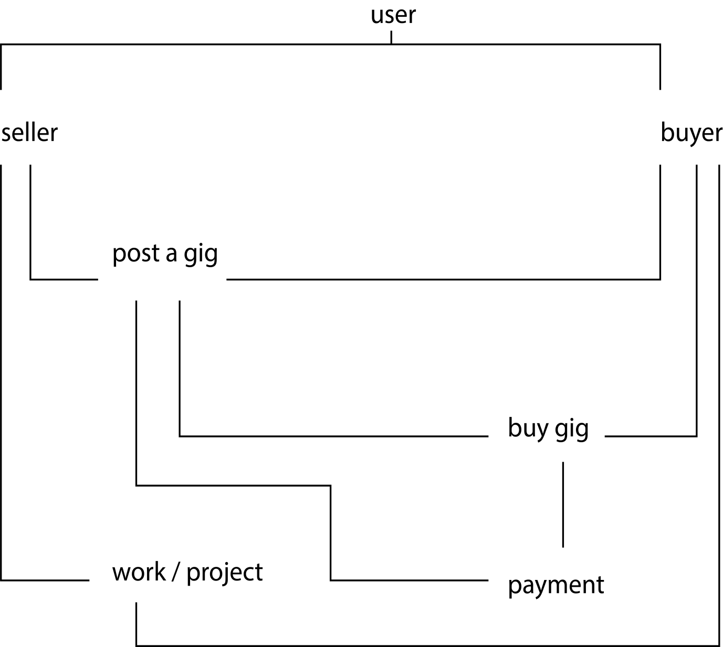

buyer side

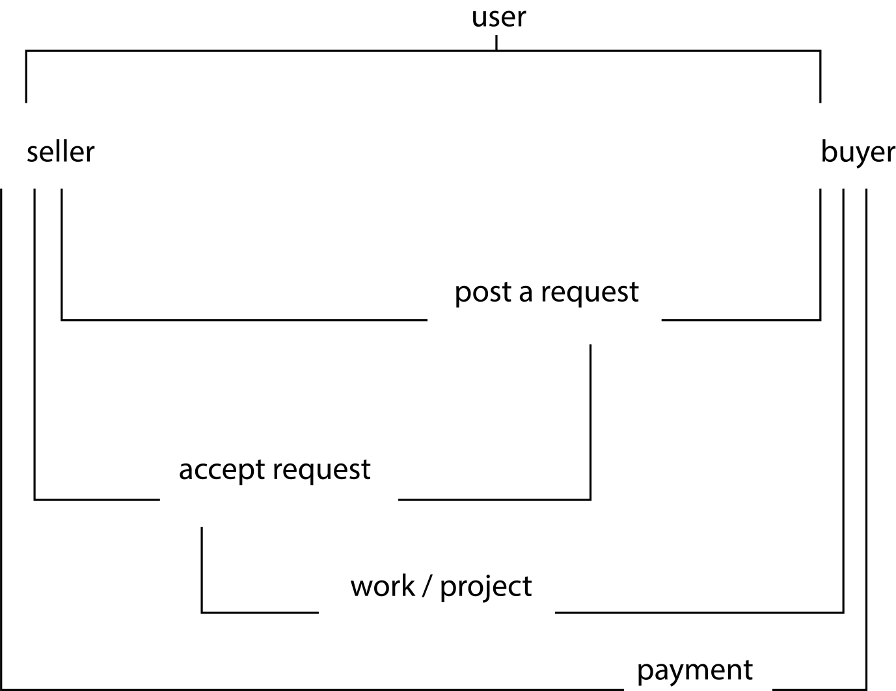

5- Web Application Architecture

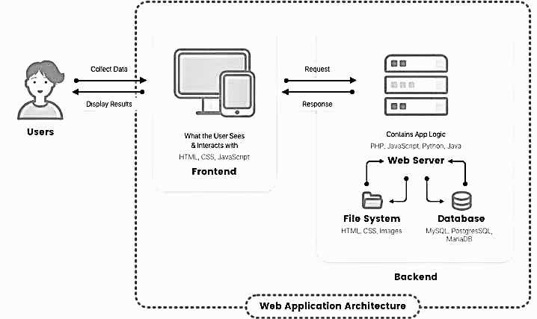

6- System Analysis

6.1- Current System

* The freelance market is currently working both digitally and offline too, there are company which work on contract and open on working days and closed when no work is assigned.
* The digital freelance market platform like fiverr, freelancer, and upwork provide as a third-party between buyers and sellers.

6.2- Problems in current system

* The different platform have their own advantages and disadvantage as below

1) Fiverr

* wide skills sets across 9 industry
* the seller upload gigs
* buyers browse the skill
* 5.5% transaction fee +2$ fee per gig purchase
* cannot apply for work

2) UpWork

* 12 industry skill set
* the client upload project
* browse project catalogue
* 5% of transaction fee
* use connect or respond to invitations

7- ScreenShots

7.1 home page

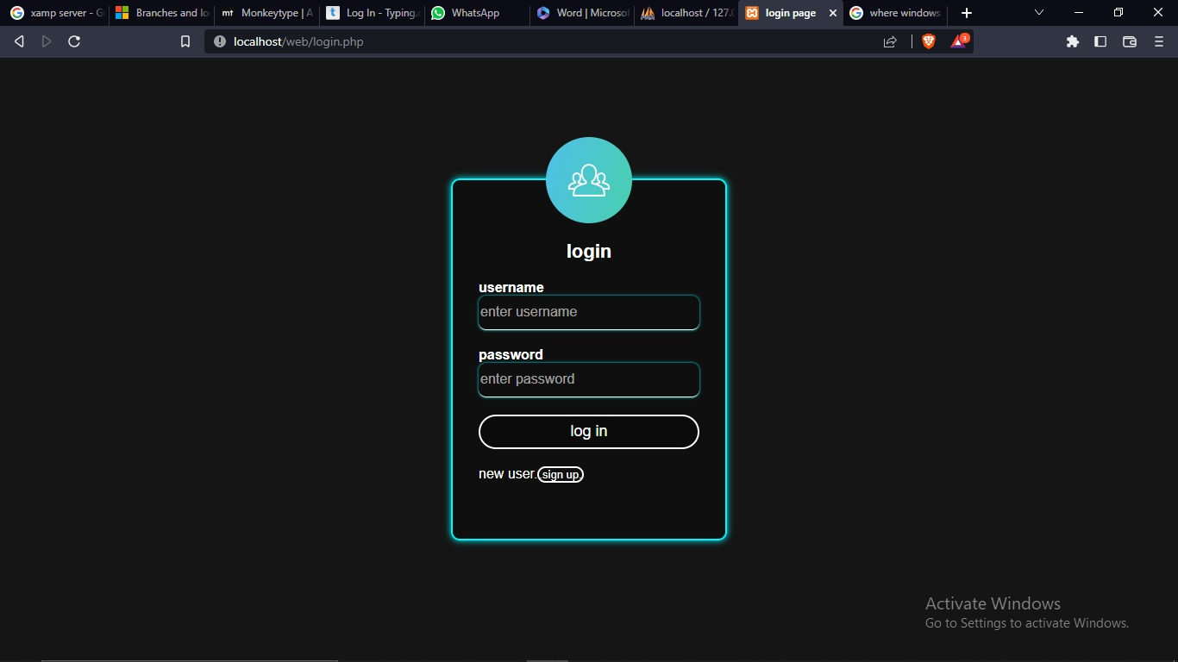

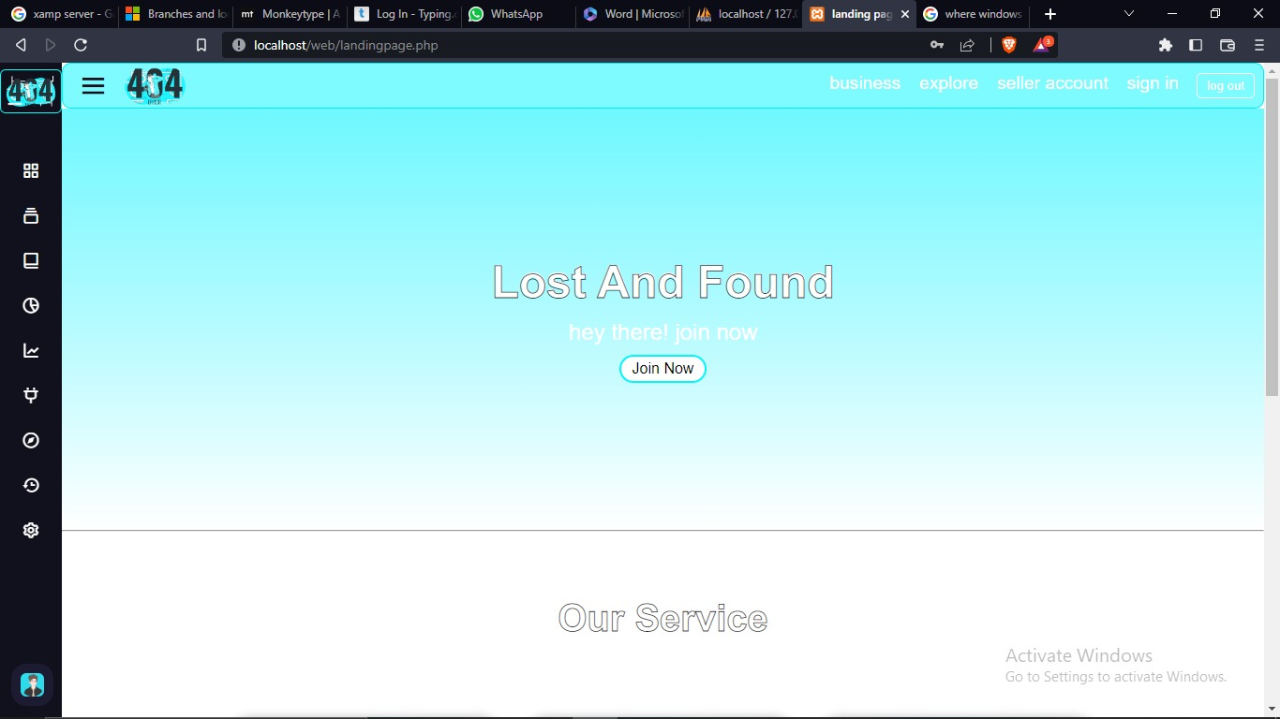

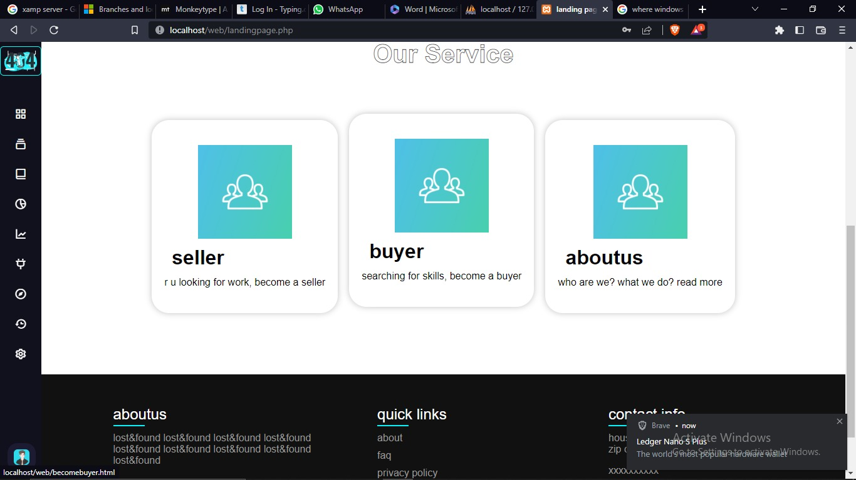

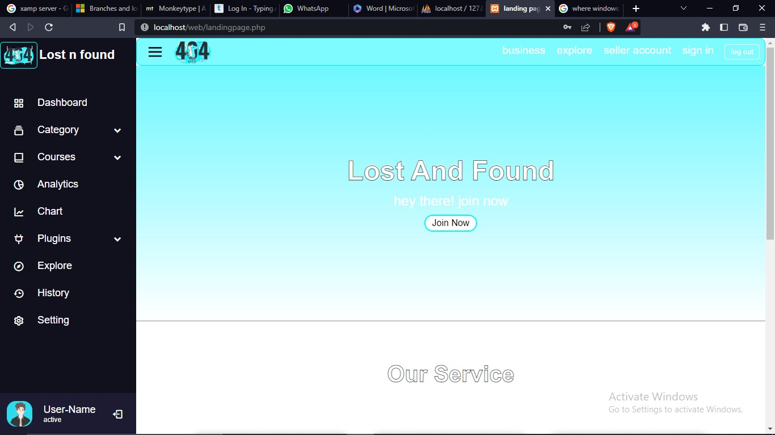

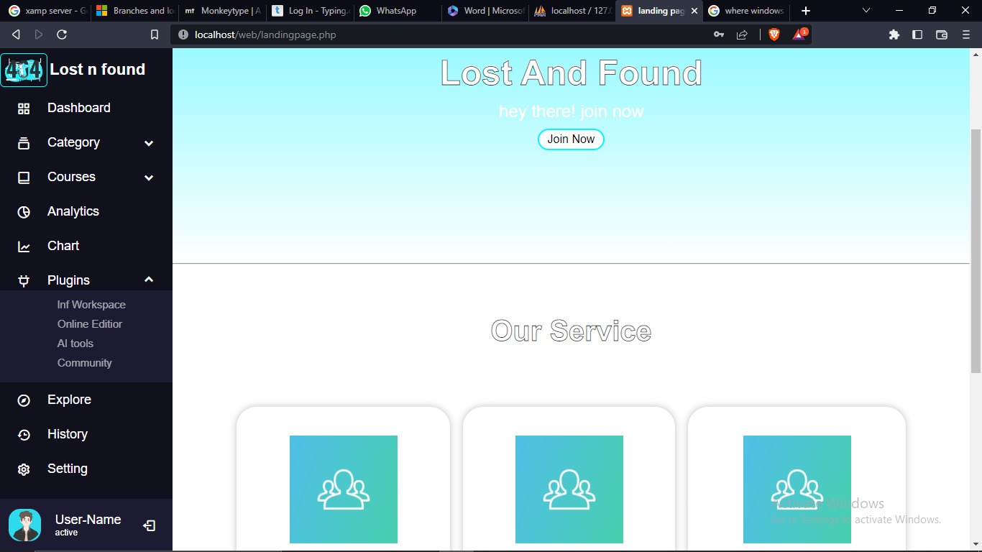

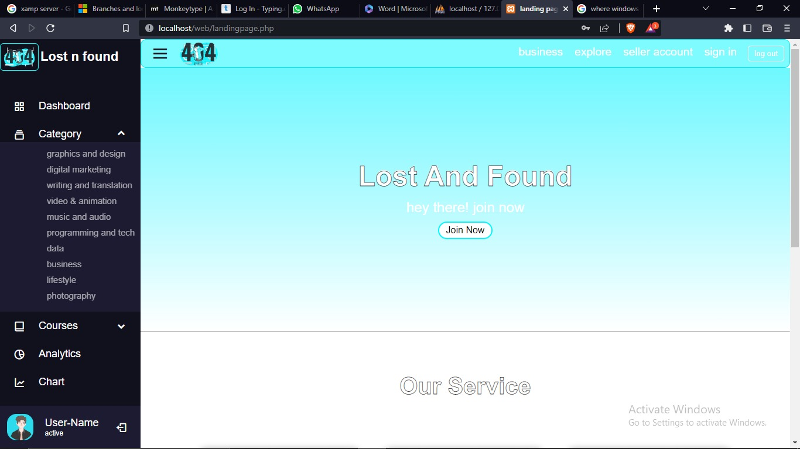

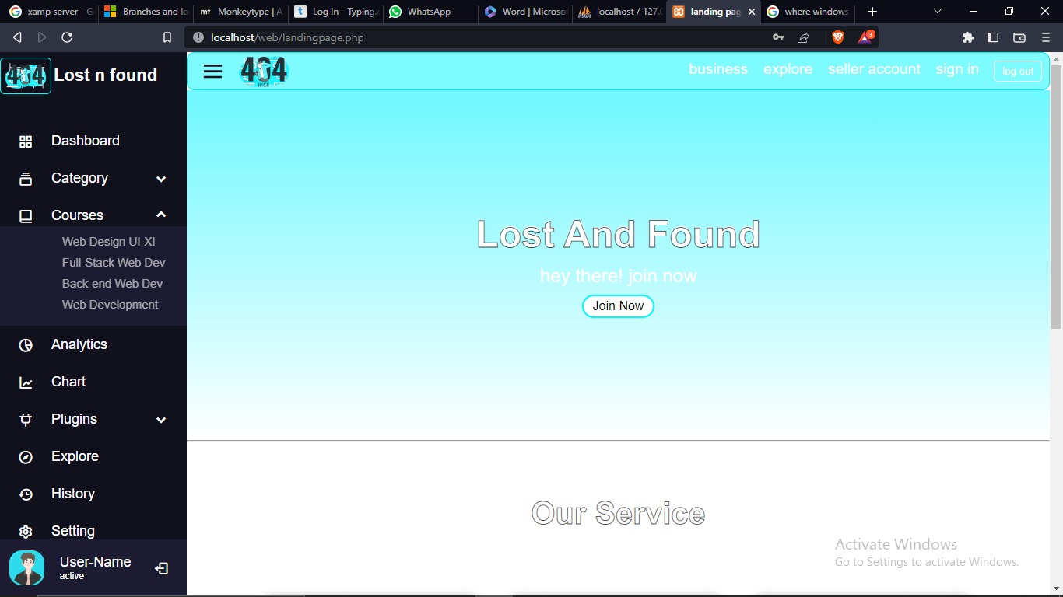

7.2 become a seller form

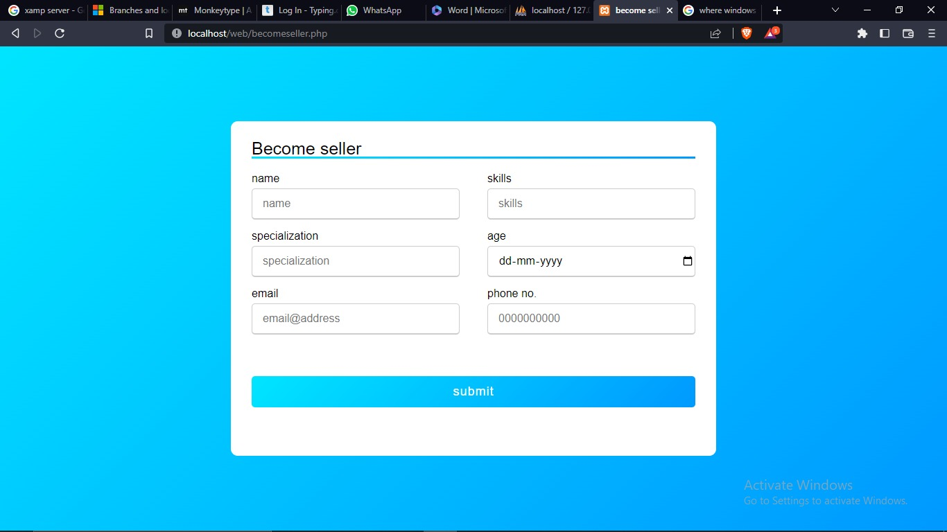

7.3 seller's home page

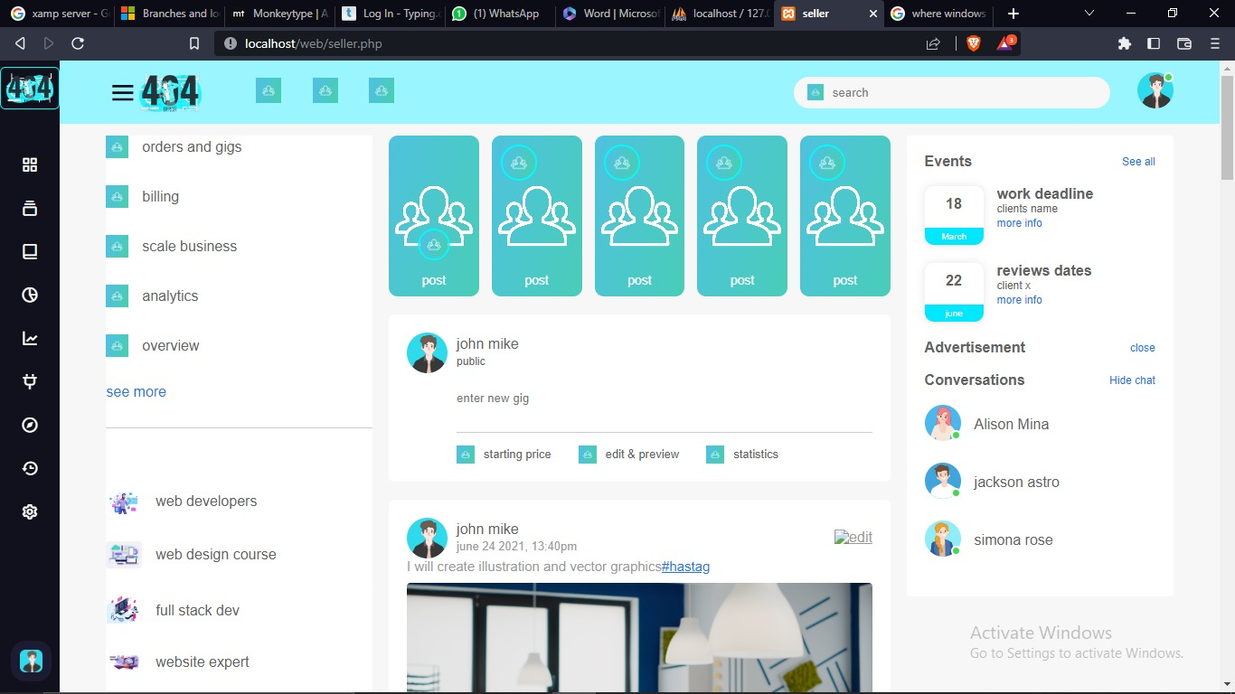

7.4 profile page

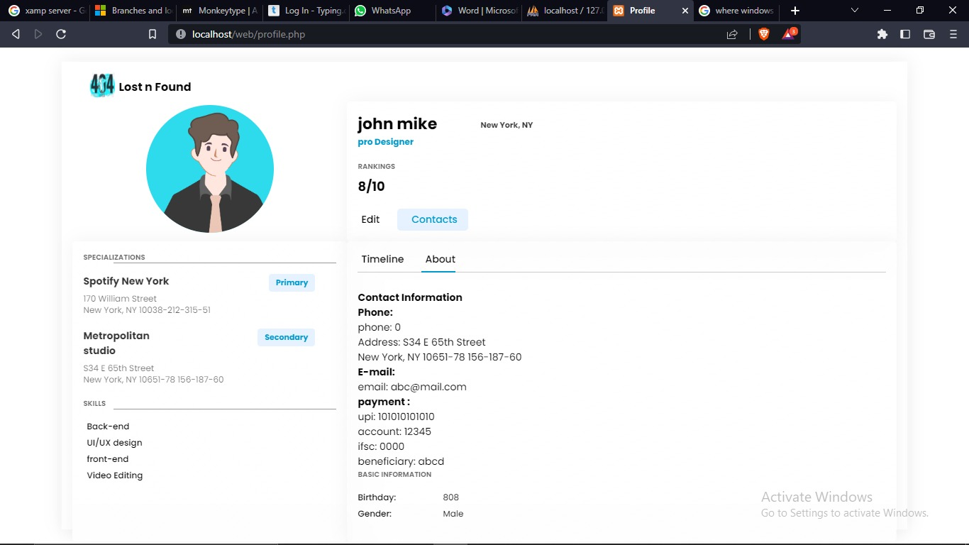

7.5 create a gig form

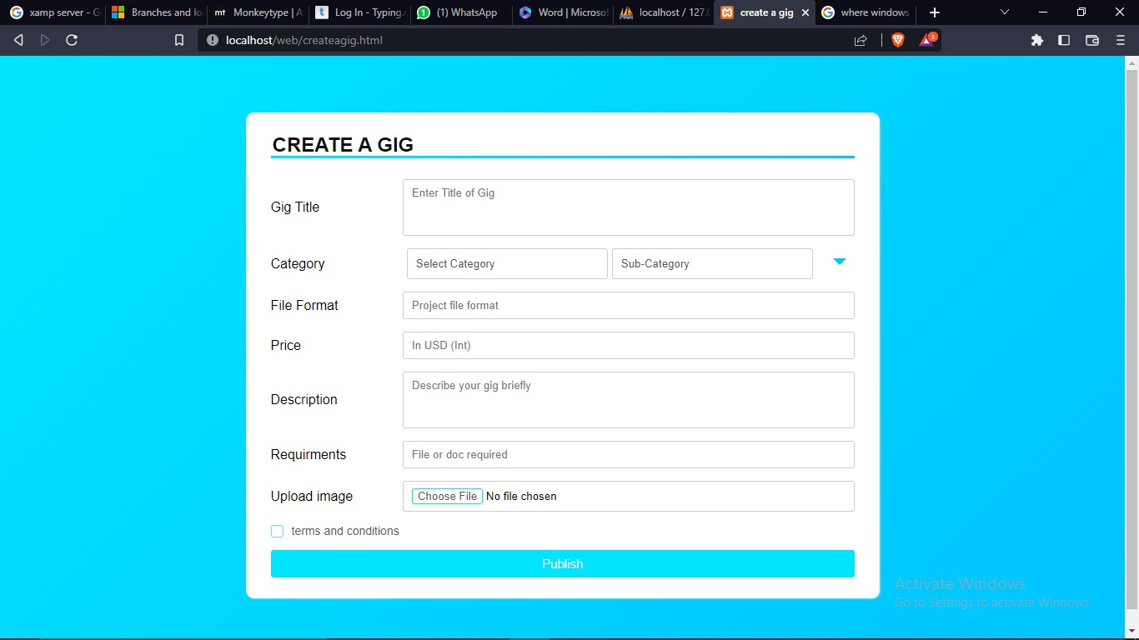

7.6 product page

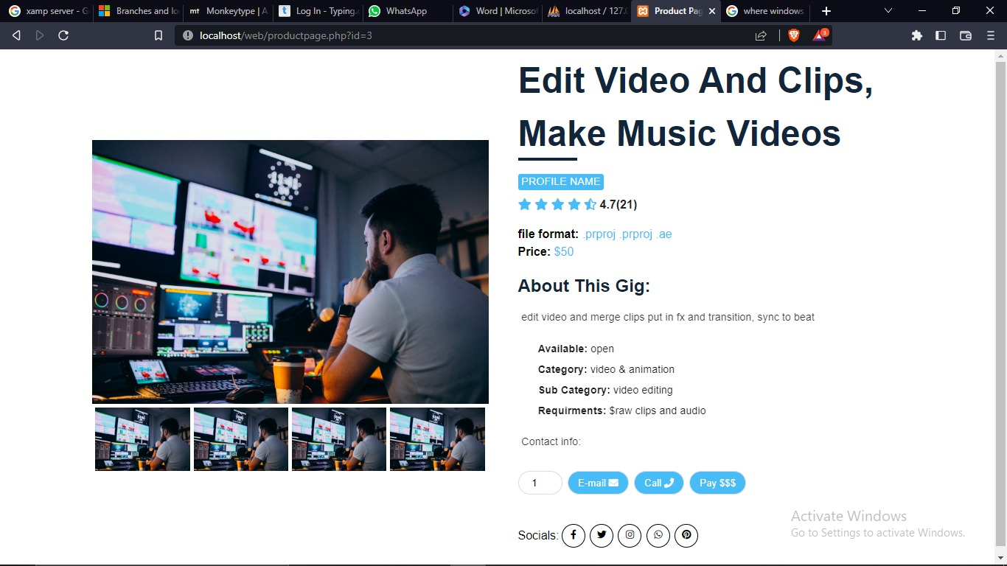

7.7 Become a buyer

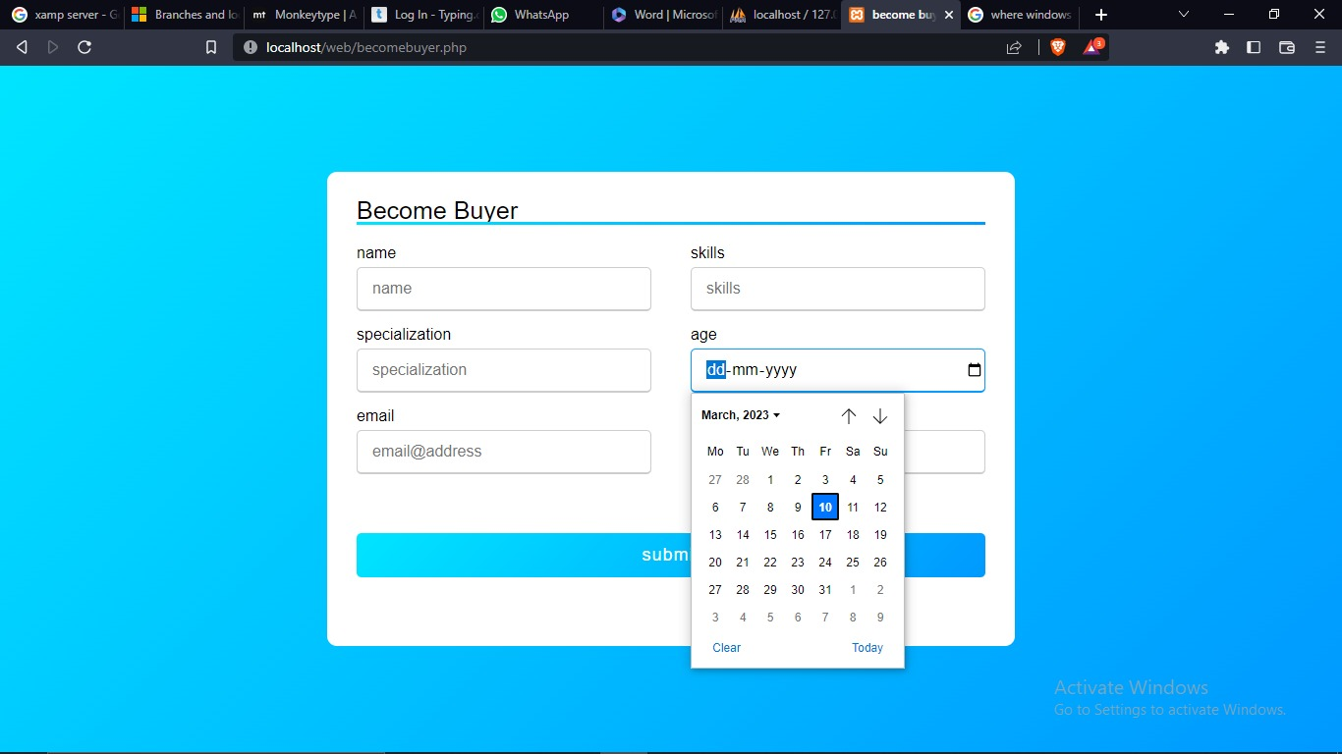

7.8 Buyer's home page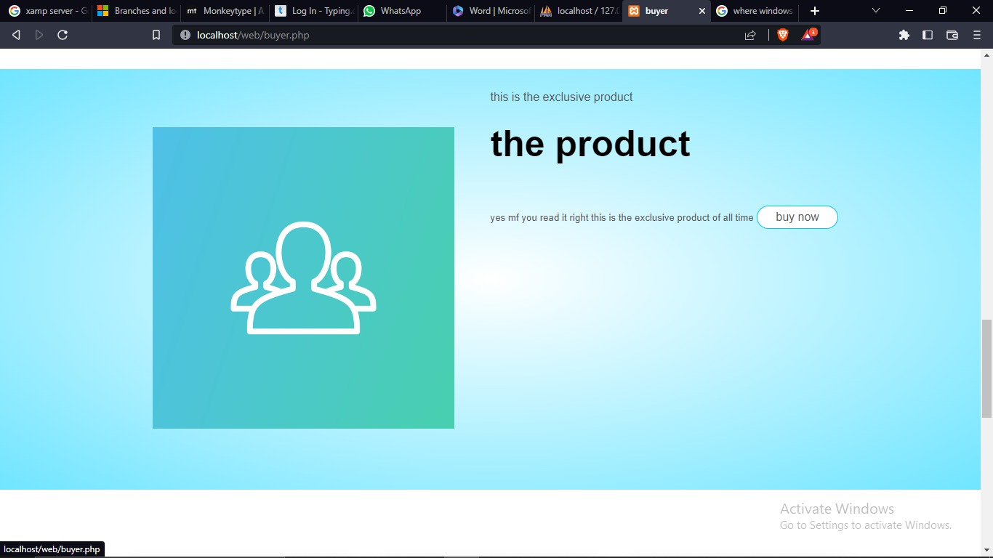

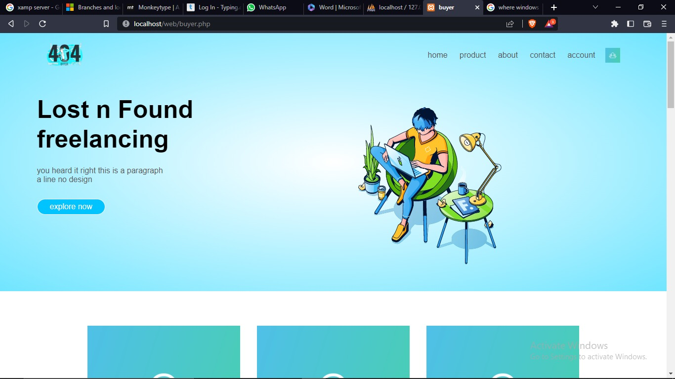

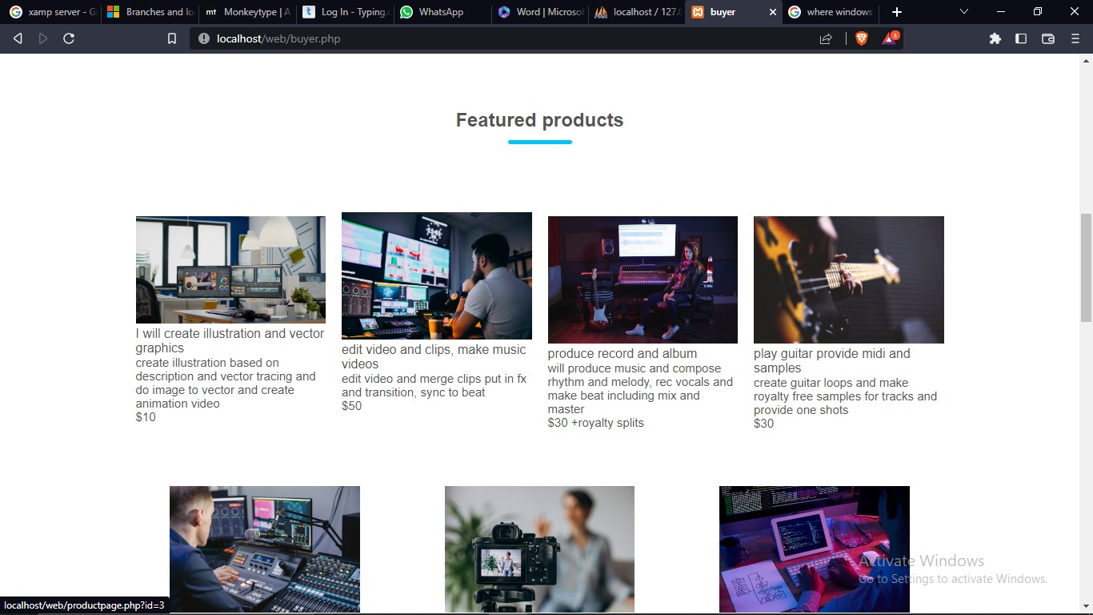

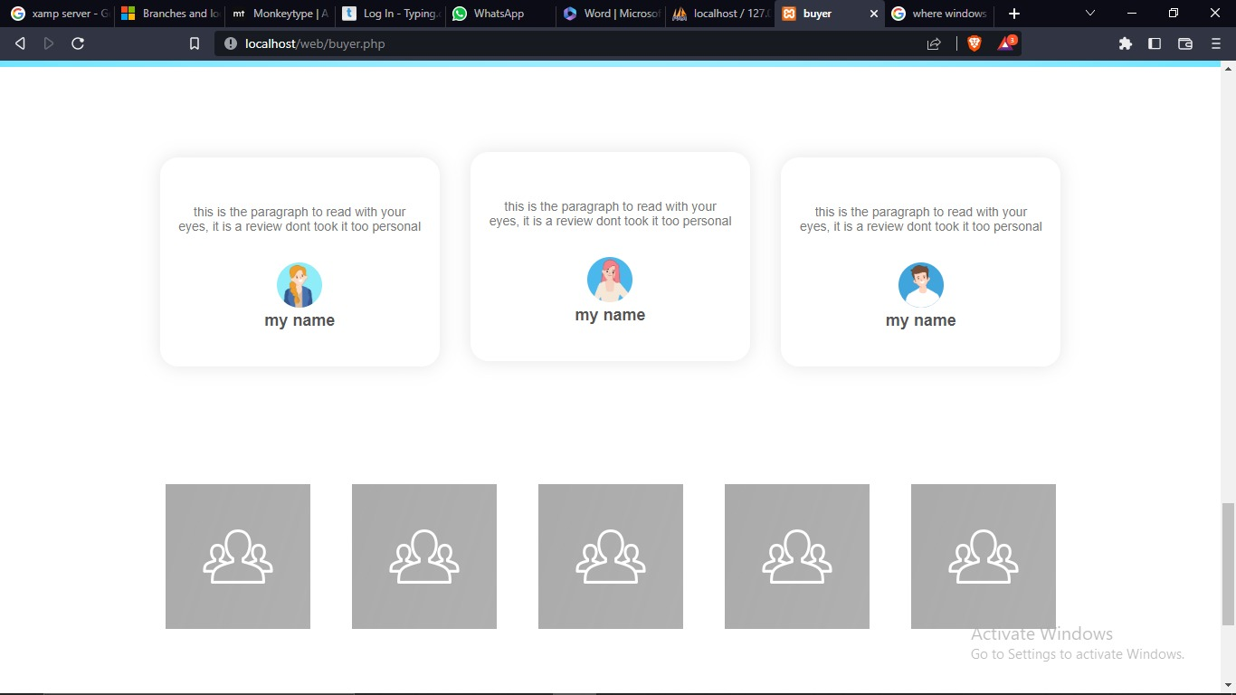

7.9 Database ScreenShot

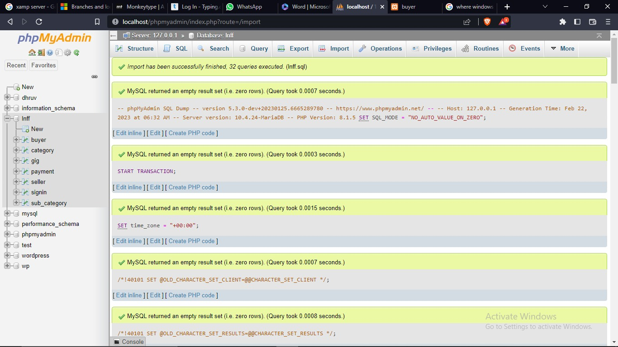

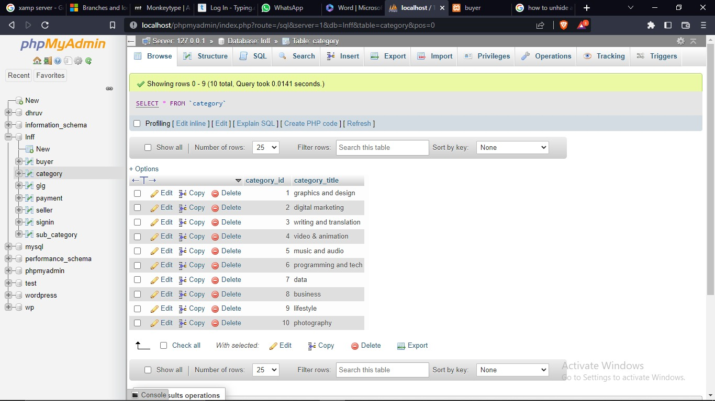

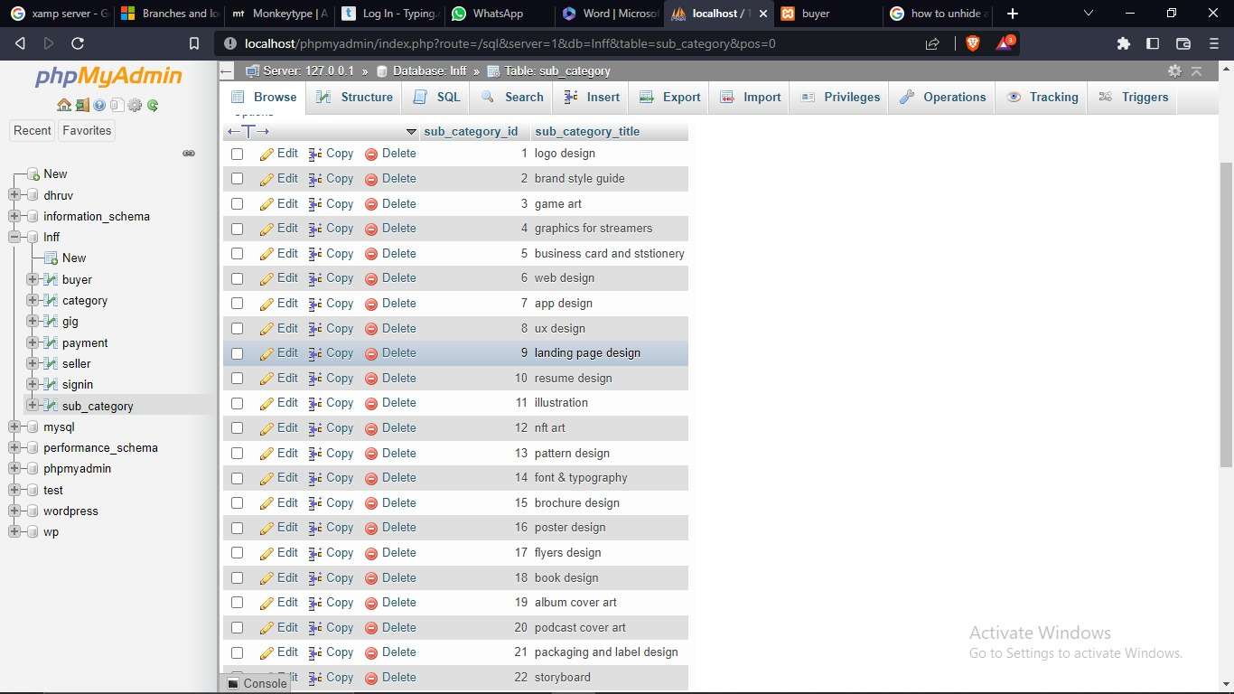

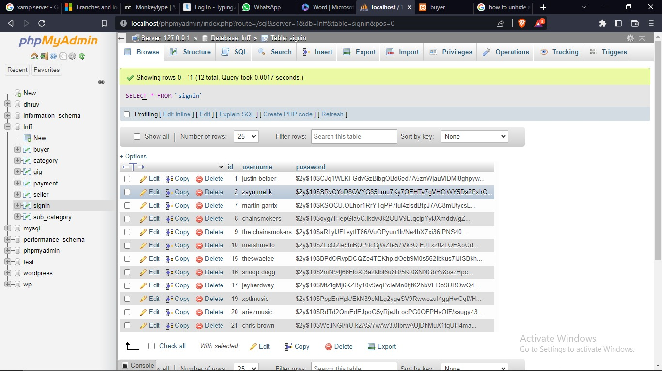

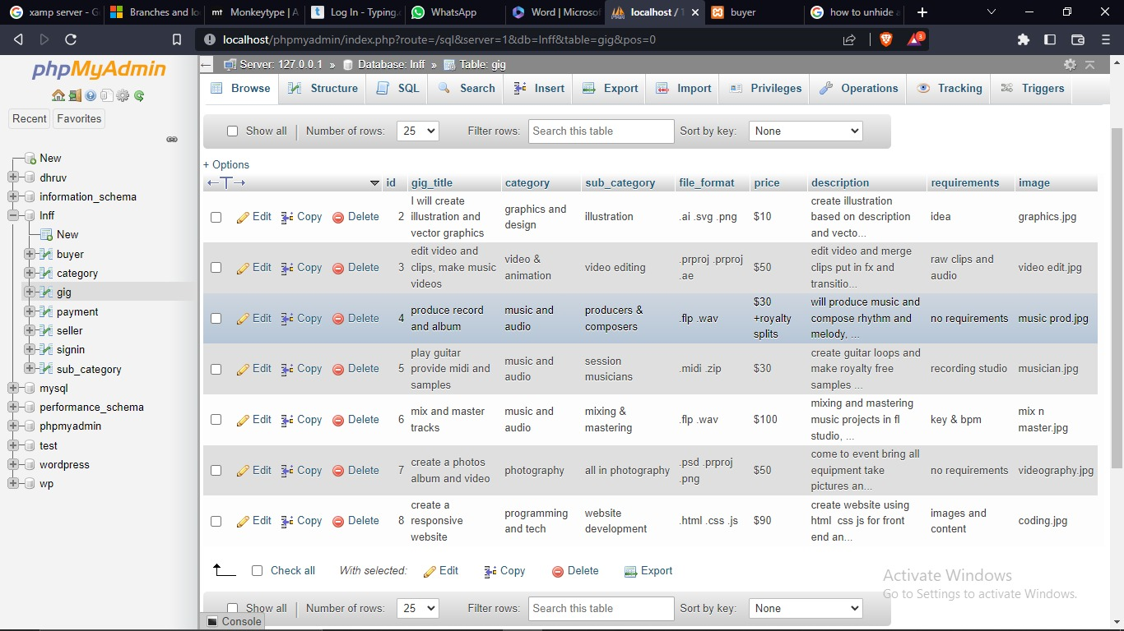

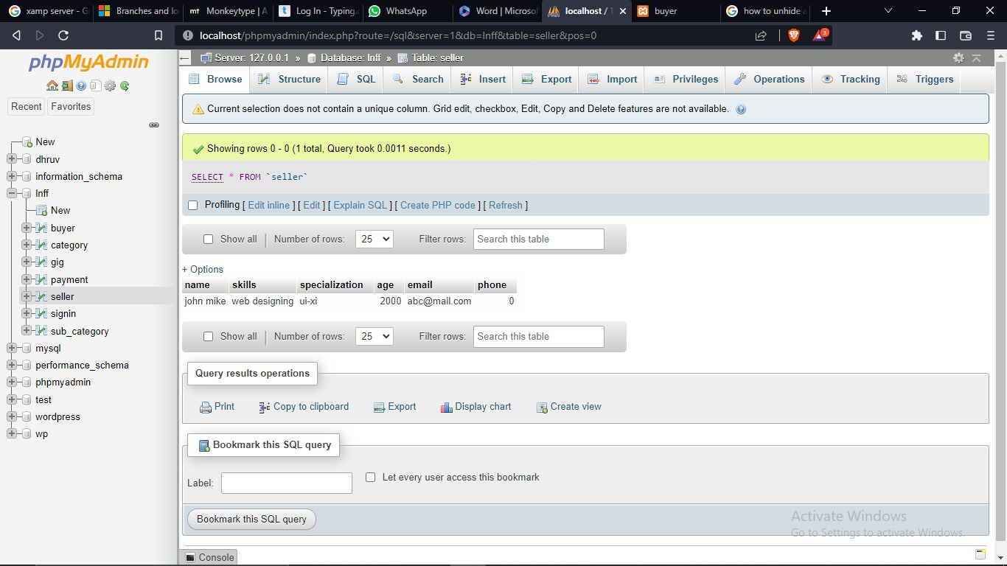

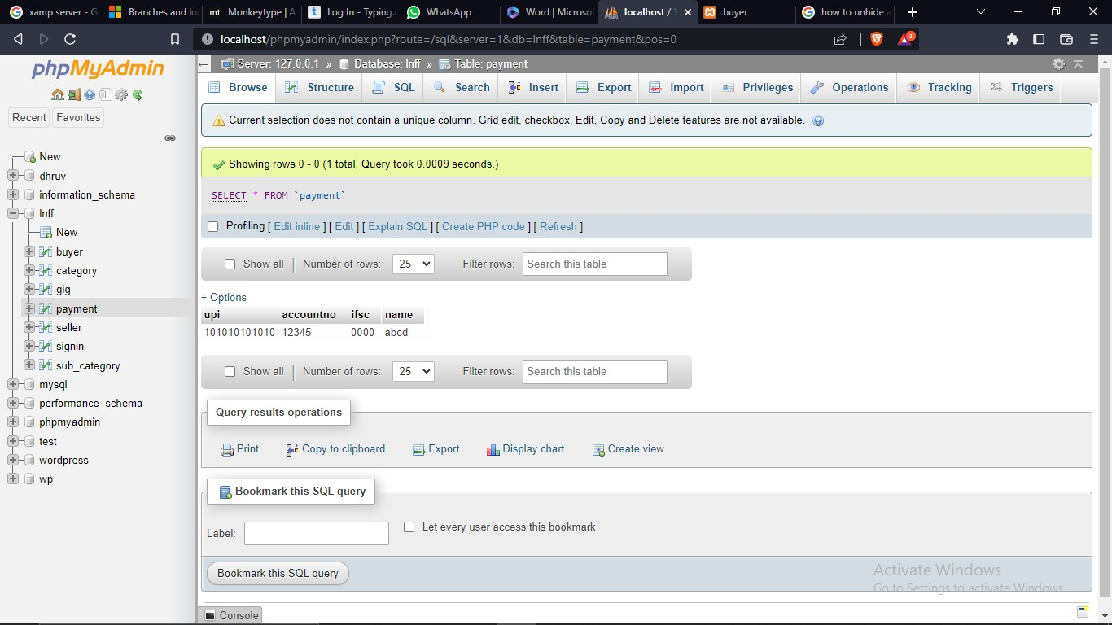

8- Innovation

The solution is to make improvement in current system. That I have done by eliminating disadvantage from most popular platform in freelance market that is fiverr and upwork.

* Provide functionality to both sell skill by uploading a gig and upload a project for clients, this way it will be two side interface.
* Will include 12 industry +other skills set not categorized.
* Reduce the transaction fee to 2%.
* This platform does not need a admin panel, cause everything is automated
* It is one time work and lifetime asset.

9- Assumption and Limitation

9.1 Assumption

* As both the features for buyers and sellers are available this application would be ideal two side interface medium between seller and buyers
* The site will be free to use.
* Transaction fee is less than 3% from current companies that is only 2%
* This will draw users attention and once it get a average traffic then it will keep growing,
* It may take years to grow that big as trust building takes time
* maybe it will require an office or workspace one day.

9.2 Limitation

* The only limitation is caused by lacking efficiency in the server, system, or browser.
* Other than that cost is one factor which will feel like waste of money to host website until it start generating revenue
* But it is an asset one day things will start to pay off.

10- Reference

* For reference I watched youtube tutorials to learn web development and refer to existing freelancing systems to study and analyse working, and functionality.
* I keep searching problem and it keep working, either from google or youtube.

10.1- websites

* www.youtube.com
* www.fiverr.com
* www.upwork.com